ENG 2D
To Kill a Mockingbird

News Report

Task: Write a news report on the next page based on the headline and
picture below. You will have to make up the facts and information to answer the 5 Ws and How. You must relate your newspaper report to both the headline and picture.

Purpose and
Audience: To report an event for the readers of a newspaper

Length: The lined paper provided indicates the length of the article.

Finch Defends Robinson Use this space
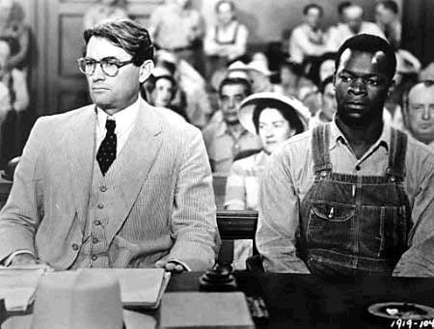
for rough work.

Who: Who:
What:
What:
Where:
Where:
When:
When:

Why:

How:

Finch Defends Robinson

_______________
__________________________________________________________________________________________________________________________________________________________________________________________________________________________________________________________________________________________________________________________________________

